SCENARIO 3: First Aid for Severe Leg Bleeding After an Earthquake

What is learning outcome?
HARD skills:
Participants receiving this training:
- Recognize life-threatening bleeding.
- Apply direct pressure effectively.
- Apply a tourniquet correctly when direct pressure fails.
- Ensure scene safety in a disaster environment.
SOFT skills:
Participants receiving this training:
- Maintain composure during emergencies.
- Make quick, accurate decisions.
- Communicate effectively with bystanders and the victim.
Description of the situation:
Following a devastating earthquake in a densely populated urban area, the participant navigates through rubble and chaos. Amidst damaged buildings and scattered debris, a young adult male is spotted near the remains of a collapsed wall. He is conscious but in visible distress, lying on the ground and crying out in pain. As the participant approaches, it becomes immediately evident that the victim has suffered a traumatic injury to his lower right leg. A deep, open wound is present, and bright red blood is spurting from the site—indicating a severe arterial hemorrhage. Blood loss is rapid, and if not quickly controlled, the victim is at risk of going into hypovolemic shock and losing consciousness. This is a critical, life-threatening emergency. The participant must first ensure the scene is safe, then promptly begin hemorrhage control interventions.

✅ Correct and timely interventions
(e.g., applying strong direct pressure immediately, correctly positioning and tightening the tourniquet, noting the time of application) will control the bleeding, stabilize the victim, and allow time for emergency responders to arrive.

❌ Incorrect, delayed, or omitted actions
(e.g., weak or misplaced pressure, delay in tourniquet application, failure to record the time) will lead to continued blood loss, loss of consciousness, or death from exsanguination.
Description of the environment: (For all scenarios, description of the environment will be same)
The scenario takes place in a densely populated urban neighborhood that has been severely impacted by a recent earthquake. The surroundings are chaotic and hazardous. Collapsed buildings dominate the landscape, and large piles of debris obstruct the streets and sidewalks. There is a fire and heavy water flow around. A thick layer of dust hangs in the air, limiting visibility. Sounds of distress echo in the background—shouts for help, distant sirens, and the occasional rumble of aftershocks. Structural instability is evident, with partially damaged walls swaying slightly and loose objects scattered across the area.
Despite the devastation, several disoriented bystanders are present, standing at a distance in shock and confusion.
Interaction – what should the participant do:
Initial safety check:
The participant moves through the debris-filled area.

✅

Check for hazards (unstable walls, fire, debris) before approaching.

❌
Go directly to the injured person without checking the scene.

- Stay calm.
    - “Let’s check the surroundings. We need to find a safe spot.”
    - “This looks like a suitable place, away from power lines and debris.”

System feedback:
✅ “The area appears safe.”

Identifying the injured person:
A scene shows a conscious adult lying on the ground

✅

Approach, confirm responsiveness, and call out for help (112)

❌
Assume the victim is fine and delay contacting emergency services.

System feedback:
✅ “Victim identified.”

    - “There is an injured person here! He looks conscious. We need to intervene immediately.”
    - "Alright, I’ll call 112 and request emergency assistance."

Situation assessment:
✅

Recognize: ‘This is arterial bleeding — I must act immediately.

❌
Think: ‘It might stop on its own; I’ll wait.

- The participant kneels next to the individual, touches his/her shoulder, and says, ““I’m here to help. Stay calm.”
- Victim says I am not feeling Okay,
- Participant says “Oh, this is a serious leg wound. The blood is bright red and spraying out—this looks like arterial bleeding.” “Stay with me, I’m going to stop the bleeding. You’re going to be okay!”
System Feedback:
✅ “Correct: Life-threatening arterial bleeding detected.”

Step 1: Apply direct pressure:
Participant

✅

Puts on gloves

❌

Grabs sterile gauze and applies firm, continuous, and direct pressure.

- Puts on gloves.
- Grabs sterile gauze or clean cloth from first aid kit.
- Applies firm, continuous, and direct pressure using both hands and your body weight to maintain a consistent force of 100–200 mmHg.
- Keeps pressure for at least 1 minute.

System Feedback:
✅ "Bleeding continues. Direct pressure is not sufficient."

❌ Mistake Feedback Options (if user fails):
- “Too little pressure applied.”
- “Wrong location — apply directly to the source of bleeding.”

Step 2: Apply a tourniquet:

The bleeding isn’t stopping. We need a tourniquet!”

Participant says “The bleeding isn’t stopping. We need a tourniquet!”
- Retrieves tourniquet device.

✅

Place the tourniquet 5–7 cm above the wound. Never over a joint

❌

Place the tourniquet over a joint

- Applies the tourniquet 5–7 cm above the wound, never over a joint.
- Tightens the strap until bleeding stops.
- Victim says, “It hurts!”, “Thank you…”
- Secures the windlass and notes the time of application.

System Feedback:
✅ "Bleeding controlled. Well done!"

Step 3: Call the ambulance and monitor the patient:
Participant
- Presses a button on the VR phone or asks a virtual character to call for help.
- Monitors the patient, talks to him and checks his condition (breathing, reaction to stimuli).

Step 4: Shock prevention:
Participant
- Takes the thermofoil and covers the patient.

Cover the victim with a thermal/emergency blanket to prevent shock.

Step 5: Completion of the scenario – arrival of rescuers:
- After all the steps have been carried out correctly, an animation of the arrival of the ambulance and the paramedics who are taking over the patient will appear
Stay with the victim. Keep talking to him until help arrives

Tools and objects
Notes for developers:
- All tools (e.g., gauze, gloves, tourniquet) must be interactive, with grabbable or drag-and-drop mechanics.
- The tourniquet should include feedback for correct placement, tightening, and locking.
- Visual cues (e.g., blood flow slowing or stopping) should indicate effectiveness of the intervention.
- The bleeding animation must respond dynamically
- Include voice prompts and verbal responses from the victim (Environmental audio should reflect chaos and urgency: sirens, aftershocks, shouting in the distance).
- Tools (e.g., gloves, gauze, tourniquet) should only become available at the appropriate step to support proper sequencing.

Tool/Object | Description | Purpose of Use | Visual Reference (example)
Gloves | Rescuer safety | 🧤 Blue medical gloves | Gloves
Sterile gauze | Initial bleeding control | 🩹 White gauze pads | Sterile gauze
Tourniquet | Severe bleeding control | ⛓️ Combat-style device | Tourniquet
Phone (Virtual interface) | In-VR interface or voice command to simulate emergency call (112/911) | To contact emergency services and receive instructions | 📱 Virtual phone icon or screen
Notebook or marker | Record application time | 🖊️ Time: 14:30 | Notebook or marker

Evaluation and feedback
Performance analysis:
- Whether the participant ensured scene safety before intervention.
- If direct pressure was applied correctly (location, duration, and force).
- If the tourniquet was applied at the correct position, tightened properly, and time of application was recorded.
- The speed and accuracy of decision-making between pressure and tourniquet.
- The participant’s ability to communicate clearly with the victim and remain calm during the emergency.
Suggestion for improvement:
- Strengths and weaknesses are reported to the participant (e.g., “Your direct pressure application was excellent, but pay more attention to apply pressure”).
Score and certification:
Participants demonstrating successful performance can earn a digital certificate of achievement.

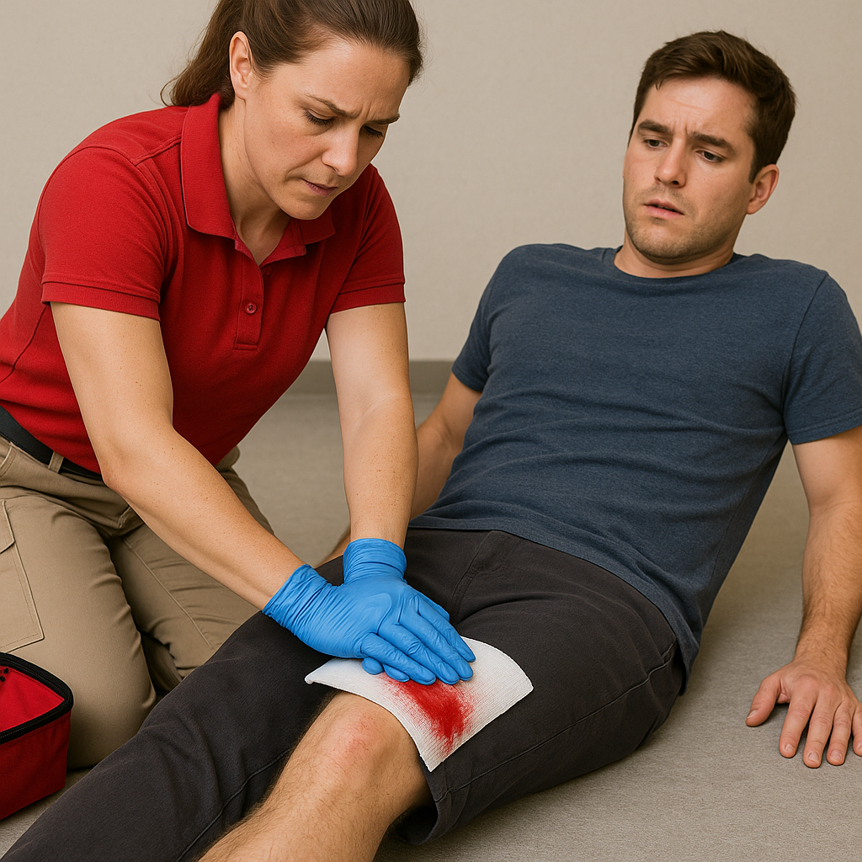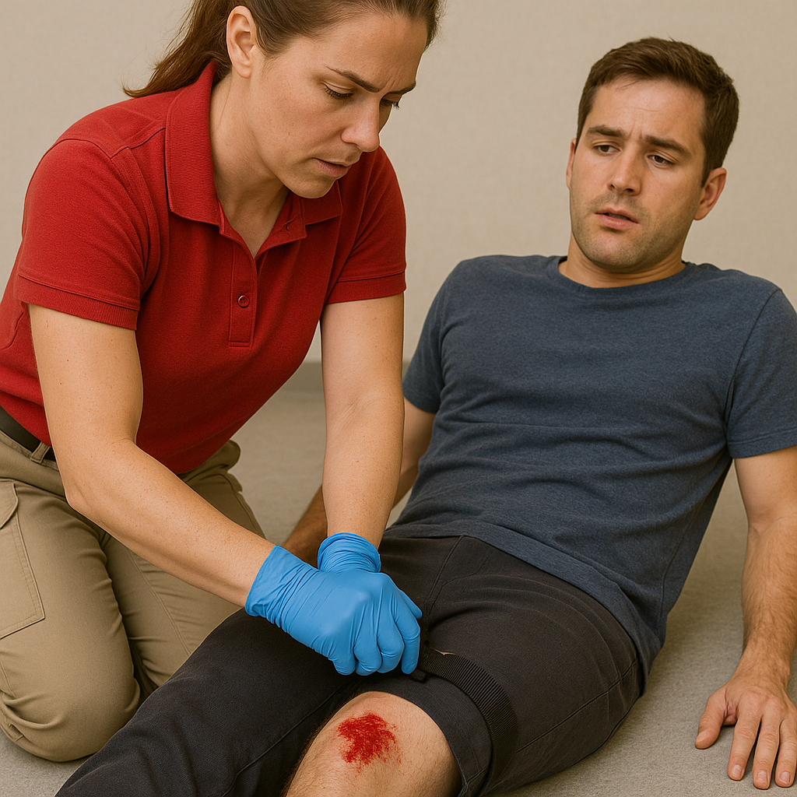

GLOSSARY OF TERMS
Bleeding: Bright red blood that spurts rhythmically; caused by damage to an artery. Life-threatening and requires immediate control.
Direct Pressure: Applying firm, continuous pressure directly over the bleeding site using sterile gauze or clean cloth.
Tourniquet: A mechanical device applied above a severe limb wound to compress blood vessels and stop arterial bleeding when direct pressure is insufficient.
Windlass: The tightening rod on a tourniquet used to apply mechanical force until bleeding stops.
Time of Application: The exact time the tourniquet is applied. Must be recorded and reported to emergency responders.

