SCENARIO 6: First Aid for a Femur Fracture During a Tornado
What is learning outcome?
HARD skills:
Participants receiving this training:
- Recognize signs and symptoms of a femur fracture.
- Apply proper leg immobilization techniques using splints or improvised materials.
- Monitor circulation below the injury site.
- Take actions to prevent shock.
SOFT skills:
Participants receiving this training:
- Stay calm and focused on extreme weather conditions.
- Reassure the injured person and communicate effectively.
Prioritize life-saving interventions and manage time efficiently.
Description of the situation:
After a violent tornado hits a rural residential area, strong winds and flying debris have caused massive destruction. Trees have fallen, power poles are down, and buildings are damaged. The participant navigates through debris and wind-blown objects while seeking survivors. A conscious adult female is seen lying on the muddy ground next to a collapsed wooden fence. She is crying out in pain and unable to move her right leg, which is visibly swollen, deformed, and angled abnormally. She reports hearing a crack and feeling severe pain when she fell. This is a suspected femur fracture, which can lead to severe internal bleeding and shock if not properly managed. The participant must stabilize the leg, calm the victim, and monitor for signs of deterioration.

✅ Correct and timely interventions

(e.g., immobilizing the leg, padding between legs, monitoring for circulation and shock, calling for emergency help) can reduce pain, prevent further injury, and improve survival.

❌ Incorrect, delayed, or omitted actions
(e.g., moving the leg, applying pressure, failing to immobilize) can cause internal bleeding, increased pain, neurovascular damage, or shock.
Description of the environment: (For all scenarios, description of the environment will be same)
The scenario takes place in a densely populated urban neighborhood that has been severely impacted by a recent earthquake. The surroundings are chaotic and hazardous. Collapsed buildings dominate the landscape, and large piles of debris obstruct the streets and sidewalks. There is a fire and heavy water flow around. A thick layer of dust hangs in the air, limiting visibility. Sounds of distress echo in the background—shouts for help, distant sirens, and the occasional rumble of aftershocks. Structural instability is evident, with partially damaged walls swaying slightly and loose objects scattered across the area.
Despite the devastation, several disoriented bystanders are present, standing at a distance in shock and confusion.
Interaction – what should the participant do:
Initial safety check:
Participant observes surroundings, checking for power line hazards, safe footing and falling debris or unstable structures.

✅

Check surroundings for falling debris, power lines, unstable structures

❌
Approach the injured victim immediately without checking hazards.

- Stay calm.
    - “We need to stay away from hanging wires and find a secure area.”
    - “This looks like a suitable place, away from power lines and debris.”

System Feedback:
✅ “Area safe. You may assist the victim.”

Identifying the victim person:
A scene shows a conscious adult lying on the ground.

✅

Approach calmly and confirm the victim is conscious and unable to move her leg.

❌
Attempt to lift the victim to a sitting positiong hazards.

    - A conscious adult female is lying on her back, holding her thigh and grimacing in pain.
    - “She’s hurt—her leg looks deformed. It might be a femur fracture.”

System Feedback:
✅ “Victim identified — suspected femur fracture.”

Situation assessment:

✅

Inspect from the side: swelling, deformity, pain, leg rotation — do NOT move the leg.

❌
Straighten the leg to see if the deformity improves.

- Participant kneels and inspects the injury. Observes include swelling, bruising, deformity in the thigh, inability to move the leg, possible leg shortening or outward rotation
- “She can’t move it, and the shape doesn’t look right. I won’t try to reposition it.”
- Calls 112 to report a femur fracture with possible internal bleeding.
System Feedback:
✅ “Correct — do not reposition a suspected femur fracture.”

Step 1: Immobolize the fracture
Participant

✅

Gather two rigid splints + padding + bandages without lifting the leg.

❌
Lift the injured leg to place splints underneath.

- Says “I’m stabilizing your leg to keep it from moving. Try to stay still.”
- Puts on gloves.
- Gathers two long, rigid splints (wood, plastic, or metal), each extending from the hip to the ankle.
- Wraps soft cloth or towel around the edges of the splints to reduce pressure and protect the skin.
- Adds soft padding, especially at the thigh, knee, and ankle areas, between the leg and the splints.
✅

Place splints along inner & outer sides of the leg, add padding, tie at thigh/knee/calf/ankle

❌
Tie only at one point and keep the splints loose to avoid discomfort.

- Gives a position along the inner and outer sides of the injured leg, without lifting or moving it.
- Uses bandages, cloth strips, or triangular scarves, the participant secures the leg at 3 to 4 points: upper thigh, just above the knee, mid-calf, around the ankle
- Ties firm enough to prevent movement, but not too tight, ensuring that circulation is not restricted.

Step 2: Prevent shock and monitor:
Participant
- Covers the victim with a blanket or coat to prevent hypothermia.
- Talks calmly to the victim: “You’re doing great. I’ve got your leg supported—help is on the way.”
- Participant continuously monitors for signs of: rapid heartbeat, weak pulse, fading consciousness

System feedback:
If actions correct → “Leg stabilized. Circulation intact. Victim calm.”
If incorrect → “Victim in pain. Circulation impaired. Risk of shock increasing.”
Tools and objects
Notes for developers:
- Victim animation must show obvious leg deformity, moaning, and limited movement.
- Provide splintable objects and allow users to drag and tie.
- Leg must not be moved; only stabilization allowed.
- Include feedback like: “Too tight – circulation impaired”, “Good immobilization.”
- Voice prompts: “My leg hurts so much…”, “I heard a snap when I fell…”
- Environment sounds: wind, debris impact, sirens, thunder, rain.

Tool/Object | Description | Purpose of Use | Visual Reference (example)
Gloves | Rescuer safety | 🧤 Blue medical gloves | Gloves
Phone (Virtual interface) | In-VR interface or voice command to simulate emergency call (112/911) | To contact emergency services and receive instructions | 📱 Virtual phone icon or screen
Splints | Wooden sticks, rods, or umbrellas | Immobilization | Splints
Cloth / Bandage | Ties or wraps | To secure the splints or bind legs | Cloth / Bandage
Padding | Clothing, towels, or foam | To cushion between legs or splints | Padding
Emergency blanket | Foil-type rescue blanket | Prevent hypothermia | Emergency blanket
Evaluation and feedback
Performance analysis:
- Recognized signs of femur fracture
- Did not attempt to reposition the leg
- Applied correct immobilization
- Checked circulation and monitored victim
- Called emergency services
- Reassured the victim and minimized movement
Suggestion for improvement:
- Strengths and weaknesses are reported to the participant (e.g., “You stabilized the leg well, but don’t forget to check foot circulation after tying.”).
Score and certification:
Participants demonstrating successful performance can earn a digital certificate of achievement.

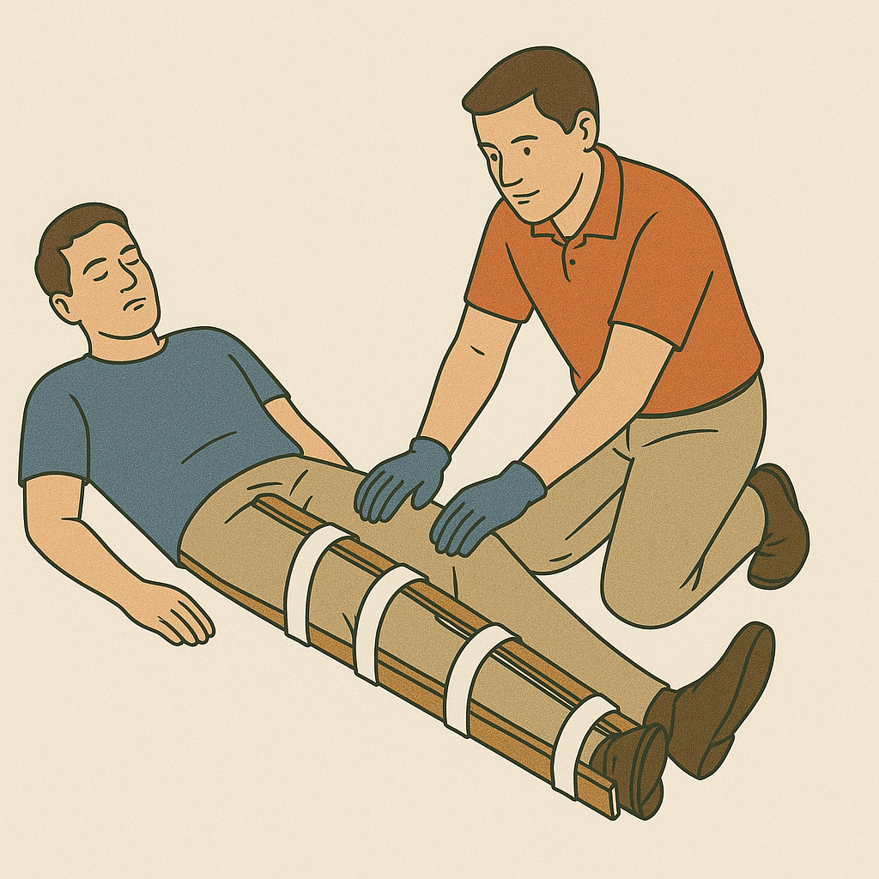
Formun Üstü

Formun Altı

GLOSSARY OF TERMS
Femur Fracture: A break in the thigh bone, often causing severe pain, deformity, swelling, and risk of internal bleeding.
Immobilization: Stabilizing the injured leg using splints, padding, and securing materials to prevent movement.
Splints: Rigid supports (wood, plastic, poles, rods, umbrellas) placed on both sides of the injured leg to hold it still.
Padding: Soft materials such as towels, folded cloths, jackets used to cushion between the leg and splints.
Bandages / Ties: Cloth strips or triangular scarves used to secure splints at multiple points.

