SCENARIO 8: Infection Prevention and Control Measures After an Earthquake

What is learning outcome?
HARD skills:
Participants receiving this training:
- Perform hand hygiene with soap and water or alcohol-based rubs
- Correctly don and doff gloves, masks, and other PPE
- Apply respiratory hygiene practices
- Safely dispose of contaminated waste and sharps
SOFT skills:
Participants receiving this training:
- Maintain composure and hygiene focus in disaster environments
- Communicate infection risks and protective practices to patients and team
- Prioritize safety for self, patient, and surroundings
Description of the situation:
A 7.3 magnitude earthquake has struck a densely populated city. Emergency shelters are being set up. The participant is deployed to a makeshift first aid zone near a collapsed building. Dozens of injured civilians are being treated under tents. Dust, debris, bodily fluids, and crowding create an extremely high risk for infection transmission. The participant must provide wound care for a young adult male with a bleeding forearm. Nearby patients are coughing and injured. PPE is available in limited supply. Hand hygiene, proper PPE use, and safe disposal must be strictly followed to prevent disease outbreaks.

✅ Correct and timely interventions

(e.g., hand hygiene, PPE use, safe wound dressing, waste segregation) protect both patient and caregiver from infection.

❌ Incorrect, delayed, or omitted actions
(e.g., no gloves, no hand hygiene, poor waste disposal) increase cross-contamination and public health risks.
Description of the environment: (For all scenarios, description of the environment will be same)
The scenario takes place in a densely populated urban neighborhood that has been severely impacted by a recent earthquake. The surroundings are chaotic and hazardous. Collapsed buildings dominate the landscape, and large piles of debris obstruct the streets and sidewalks. There is a fire and heavy water flow around. A thick layer of dust hangs in the air, limiting visibility. Sounds of distress echo in the background—shouts for help, distant sirens, and the occasional rumble of aftershocks. Structural instability is evident, with partially damaged walls swaying slightly and loose objects scattered across the area.
Despite the devastation, several disoriented bystanders are present, standing at a distance in shock and confusion.
Interaction – what should the participant do:
1. Prepare for care (before contact):
Participant

✅

Perform hand hygiene and put on gloves/mask before touching the patient

❌
Start wound care immediately without hand hygiene or PPE.

- Says “Let me sanitize my hands and put on gloves before touching the wound.”
    - Puts on gloves and mask using correct donning technique.
    - Uses hand sanitizer or soap and water.
    - Checks that sharps disposal and waste bins are available.

System Feedback:
✅ “Hand hygiene completed. PPE worn correctly.”

2. Assess wound and environment:
Participant

✅

Ask coughing individuals to wear a mask and provide one if needed.

❌
Ignore coughing people — continue wound care without addressing respiratory hazards.

    - Approaches patient calmly.
    - Observes coughing individuals nearby and asks them to wear masks.
    - Provides patient a tissue or mask if needed (respiratory hygiene).
System Feedback:
✅ “Respiratory hygiene applied.”

3. Wound care and dressing:
Participant

✅

Use clean water/antiseptic, avoid touching sterile gauze with contaminated fingers.

❌
Use the same dirty cloth to wipe the wound multiple times.

- Cleans wound using clean water or antiseptic.
- Applies sterile gauze without touching inner surface.
- Avoids cross-contamination by using one hand for clean tools and one for contact.
- Says “This dressing is clean and sterile. Try not to touch it.”

System Feedback:
✅ “Dressing applied safely.”

4. Waste disposal and doffing:
Participant
✅

Dispose of used gloves, gauze, and tissues into labeled infectious waste bin

❌
Throw used gauze and gloves on the ground or into regular trash.

- Places used gloves, gauze, tissues in labeled infectious waste bin.
- Disposes of sharps (if used) into puncture-resistant sharps container.
- Removes PPE in correct order without self-contamination.
- Performs hand hygiene again after PPE removal.

System feedback:
If actions correct → “Hand hygiene completed. Gloves worn properly.”, “Wound cleaned and covered with sterile dressing.”, “Used PPE disposed of safely.”

If incorrect “No hand hygiene – contamination risk increased.”, “Gloves removed incorrectly – self-contamination possible.”, “Sharps disposed in wrong bin – safety violation.”

Tools and objects
Notes for developers:
- Include realistic donning and doffing of PPE with step prompts.
- Trigger feedback if gloves are not worn, or hand hygiene skipped.
- Add ambient risk: coughing NPCs, blood on surfaces, supply scarcity.
- Include a “contamination alert” animation if participant touches a wound without PPE.
- Allow drag-and-drop waste disposal and timed infection control steps.

Tool/Object | Description | Purpose of Use | Visual Reference (example)
Gloves | Rescuer safety | 🧤 Blue medical gloves | Gloves
Surgical mask | Worn by participant and coughing patients | Prevent respiratory droplet spread | Surgical mask
Hand sanitizer/soap | For before and after patient contact | Core of infection control | Hand sanitizer/soap
Sterile gauze & wipes | For wound cleaning and dressing | Maintain asepsis | Sterile gauze & wipes
Waste bags (marked) | For infectious and general waste | Environmental hygiene | Waste bags (marked)
Sharps container | Hard plastic with puncture resistance | Safe sharps disposal | Sharps container
Evaluation and feedback
Performance analysis:
- Performed hand hygiene before and after patient contact.
- Selected appropriate PPE and worn them correctly.
- Completed wound care using sterile technique.
- Applied respiratory hygiene and cough etiquette.
- Contaminated materials and sharps disposed safely.
Suggestion for improvement:
- Strengths and weaknesses are reported to the participant (e.g., “Good wound care, but be sure to sanitize again after glove removal.” , “You forgot to ask coughing patients nearby to wear masks — try to reduce exposure.”).
Score and certification:
Participants demonstrating successful performance can earn a digital certificate of achievement.

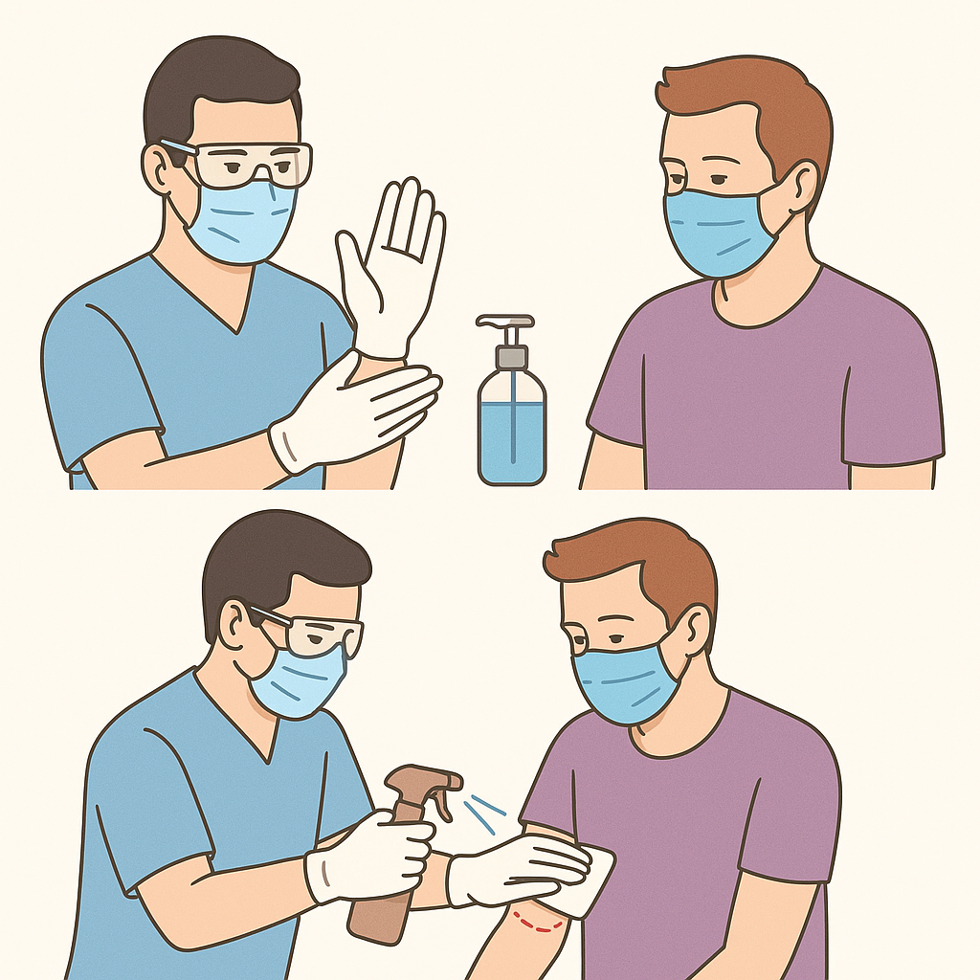

GLOSSARY OF TERMS
Hand Hygiene: Cleaning hands with soap & water or alcohol-based sanitizer to prevent infection spread.
PPE (Personal Protective Equipment): Protective gear (gloves, masks, gowns) used to reduce infection transmission.
Donning: Correct process of putting on PPE in the proper order to maintain sterility.
Aseptic Technique: Procedures used to prevent contamination when treating wounds.
Infectious Waste: Contaminated materials (gloves, gauze, bodily-fluid–soaked items) requiring special disposal.
Sterile Dressing: Clean medical covering that protects a wound from contaminants.
Environmental Hygiene: Maintaining a clean, safe environment by proper waste disposal and minimizing contamination.
Self-Contamination: Accidental exposure caused by improper PPE handling or hygiene practices.
Infection Transmission: Spread of pathogens through contact, droplets, contaminated surfaces, or unclean hands.
Formun Üstü

