SCENARIO 5: First Aid for an Open Abdominal Injury During a Flood

What is learning outcome?
HARD skills:
Participants receiving this training:
- Identify the signs of an open abdominal wound.
- Avoid touching or replacing protruding organs.
- Cover the wound correctly with moist sterile material.
- Monitor signs of shock and deterioration.
SOFT skills:
Participants receiving this training:
- Stay calm and focused in a high-stress, hazardous environment.
- Communicate effectively with the injured person.
Act quickly and prioritize life-saving interventions.
Description of the situation:
After a major flood submerges much of a residential neighborhood, the participant moves through murky, debris-filled water in search of survivors. Amid collapsed fences and submerged vehicles, an adult female is found lying on her back, groaning in pain. Her clothes are soaked and torn. As the participant gets closer, it's clear that she has suffered a deep, open abdominal injury, with bowel loops visibly protruding from the wound. The victim is conscious, pale, and in shock. She is trying to sit up and touch the exposed organs, unaware that this may cause further harm. This is a life-threatening emergency. The wound must be protected from further contamination, and the victim must be stabilized without applying pressure or trying to push the organs back in.

✅ Correct and timely interventions

(e.g., keeping the victim still, covering the wound with moist sterile dressing, preventing shock, calling for help) can protect internal organs, prevent infection, and save the victim’s life.

❌ Incorrect, delayed, or omitted actions
(e.g., trying to push organs back inside, applying pressure, using dry or dirty material) can cause severe infection, internal damage, shock, or death.
Description of the environment: (For all scenarios, description of the environment will be same)
The scenario takes place in a densely populated urban neighborhood that has been severely impacted by a recent earthquake. The surroundings are chaotic and hazardous. Collapsed buildings dominate the landscape, and large piles of debris obstruct the streets and sidewalks. There is a fire and heavy water flow around. A thick layer of dust hangs in the air, limiting visibility. Sounds of distress echo in the background—shouts for help, distant sirens, and the occasional rumble of aftershocks. Structural instability is evident, with partially damaged walls swaying slightly and loose objects scattered across the area.
Despite the devastation, several disoriented bystanders are present, standing at a distance in shock and confusion.

Interaction – what should the participant do:
Initial safety check:
Participant observes surroundings, checking for electrical hazards, strong water currents, and sharp debris.

✅

Check the surroundings for water currents, debris, electrical hazards, collapsing walls.

❌
Approach the victim immediately without checking the environment.

- Stay calm.
    - “Let's make sure the area is safe first.”

    - “This looks like a suitable place, away from power lines and debris.”

System feedback:
✅ “The area appears safe.”

Identifying the victim person:
A scene shows a conscious adult lying on the ground.

There is an injured and conscious person here! . I need to act fast.

System feedback:
✅ “Victim identified.”

    - A conscious adult female is lying on her back, visibly injured, and in distress.
    - “She’s seriously injured. That looks like an open abdominal wound. I need to act fast.”

Situation assessment:
- Participant kneels and inspects the injury. Observes include deep abdominal laceration, protruding intestinal loops, pale and clammy skin, rapid breathing

There’s organ exposure- I must not touch them or push them back in

System feedback:
✅ “Correct assessment: Open abdominal injury.”

- Participant says “There’s organ exposure — I must not touch them or push them back in.”

Step 1: Protect the wound
Participant
- Puts on gloves.
- Gathers clean moist sterile dressing (or uses clean cloth soaked in water if sterile material is unavailable).
- Covers the wound and exposed organs without applying pressure.
- Does not attempt to push anything back inside.
- Says “I’m going to cover the wound to keep it moist and clean — try not to move.”

I’m covering the wound to keep it moist and clean — try not to move.
✅
Moist sterile dressing applied.
❌
Organs touched or pushed inward.

Step 2: Prevent shock and monitor:
Participant
- Gives a position for the victim in a supine position, knees slightly bent (Victim animation should support slight knee bend if environment and position permit) to reduce abdominal tension.
- Covers with thermal/emergency blanket to prevent heat loss.
- Talks calmly to the victim: “You’re doing great. Stay still. Help is on the way.”

✅

Gives a position for the victim in a supine position
❌
Covers with thermal/emergency blanket

System feedback:
✅ “Wound protected. Victim stabilized.”
❌ “Improper positioning — abdominal tension increasing.”
‘Open abdominal injury with organ exposure, conscious victim, signs of shock.’

- Calls 112 and gives a clear situation report.

System feedback:
If actions correct → “Wound protected. Victim stabilized.”
If incorrect (e.g., organ manipulation, dry cloth) → “Victim in pain. Condition worsening due to improper wound care.”
Tools and objects
Notes for developers:
- Victim animation should show exposed organs and protective response (trying to touch wound).
- Interactive tools must allow user to: select moist dressing, place gently over wound, avoid incorrect actions like pushing organs in
- Include feedback prompts (positive/negative).
- Voice lines from victim: “It hurts… what’s happening?”, “Please help… my stomach…”
- Soundscape: Water flow, sirens, shouting, helicopters.
- Make sure objects are only usable in correct step order.

Tool/Object | Description | Purpose of Use | Visual Reference (example)
Gloves | Rescuer safety | 🧤 Blue medical gloves | Gloves
Phone (Virtual interface) | In-VR interface or voice command to simulate emergency call (112/911) | To contact emergency services and receive instructions | 📱 Virtual phone icon or screen
Moist dressing | Sterile dressing or clean cloth soaked in clean water | To cover and protect exposed organs | Moist dressing
Emergency blanket | Foil-type rescue blanket | Prevent hypothermia | Emergency blanket

Evaluation and feedback
Performance analysis:
- Select appropriate material to cover wound.
- Avoid manipulating exposed organs.
- Prevent shock and monitor vital signs.
- Communicate calmly and call emergency services.
Suggestion for improvement:
- Strengths and weaknesses are reported to the participant (e.g., “You covered the wound properly, but remember to bend the knees slightly to reduce abdominal tension.”).
Score and certification:
Participants demonstrating successful performance can earn a digital certificate of achievement.

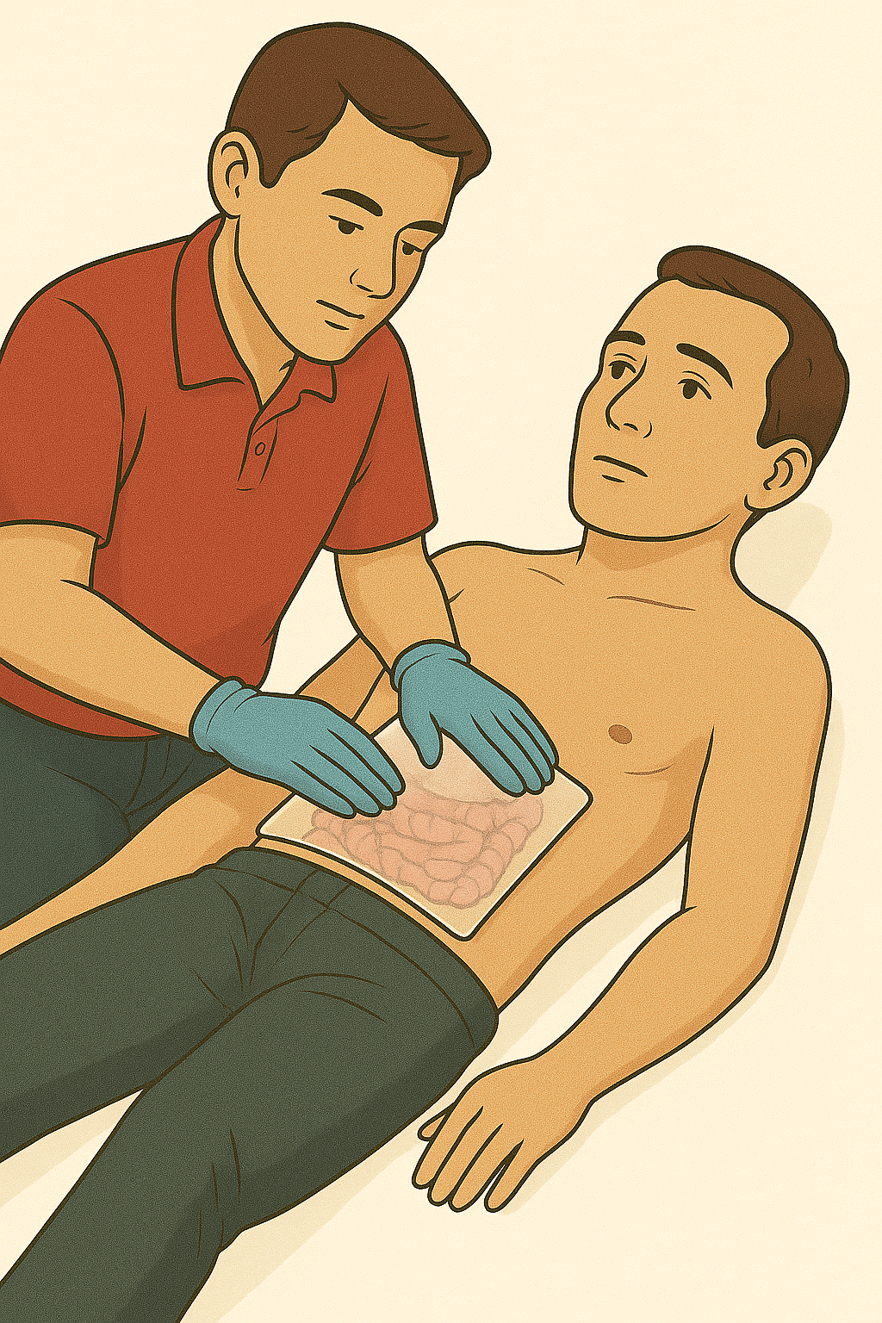

GLOSSARY OF TERMS
Open Abdominal Wound: A traumatic injury in which the abdominal wall is cut open and internal organs may be exposed.
Evisceration: Protrusion of internal organs—usually intestines—outside the abdominal cavity through a wound.
Moist Sterile Dressing: A sterile cloth or pad moistened with clean water or saline, used to protect exposed organs without causing tissue damage.
Supine Position: Victim lying flat on their back.
Do Not Apply Pressure: A key safety principle stating that pressure should never be placed on an open abdominal wound or exposed organs.

