SCENARIO 4: First Aid for an Open Chest Injury During a Flood
What is learning outcome?
HARD skills:
Participants receiving this training:
- Identify the signs of an open chest wound (sucking chest wound).
- Create an occlusive (sealed) dressing using available materials.
- Position the patient to optimize breathing.
SOFT skills:
Participants receiving this training:
- Stay calm and focused in a high-stress, hazardous environment.
- Communicate effectively with the injured person.
- Act quickly and prioritize life-saving interventions.
Description of the situation:
Following a severe flood that has struck a residential area, the participant navigates through deep, moving water filled with floating debris. Streets are submerged, and panicked survivors are seen wading through the current. Amidst the chaos, the participant notices an adult male leaning against a damaged car, breathing heavily and clutching his chest. As the participant approaches, it becomes clear that the victim has sustained a penetrating injury to the right side of his chest — an open chest wound. With every breath, a sucking sound is heard from the wound, and bubbles appear with blood — indicating a sucking chest wound. He is conscious, pale, and in visible respiratory distress. This is a life-threatening emergency. Air is entering the chest cavity, reducing lung expansion and oxygenation. Immediate first aid is necessary to seal the wound and support breathing.

✅ Correct and timely interventions

(e.g., sealing the wound with an occlusive dressing, allowing air to escape on one side, monitoring breathing) may prevent the development of tension pneumothorax and improve the victim’s chances of survival.

❌ Incorrect, delayed, or omitted actions
(e.g., sealing all sides, doing nothing, failing to call for help) can cause respiratory failure, shock, or death.
Description of the environment: (For all scenarios, description of the environment will be same)
The scenario takes place in a densely populated urban neighborhood that has been severely impacted by a recent earthquake. The surroundings are chaotic and hazardous. Collapsed buildings dominate the landscape, and large piles of debris obstruct the streets and sidewalks. There is a fire and heavy water flow around. A thick layer of dust hangs in the air, limiting visibility. Sounds of distress echo in the background—shouts for help, distant sirens, and the occasional rumble of aftershocks. Structural instability is evident, with partially damaged walls swaying slightly and loose objects scattered across the area.
Despite the devastation, several disoriented bystanders are present, standing at a distance in shock and confusion.
Interaction – what should the participant do:
Initial safety check:
Participant observes surroundings, checking for electrical hazards, fast water currents, and sharp debris.
- Stay calm.

✅

Move to a stable, safe area away from fast water and debris.

❌
Approach immediately without checking hazards.

    - “Let’s stay away from power lines and find stable footing.”
    - “This looks like a suitable place, away from power lines and debris.”

System Feedback:
✅ “Environment safe. You may proceed.”

Identifying the victim person:
A scene shows a conscious adult sitting on the ground.

✅

Approach slowly and confirm the victim is conscious and breathing

❌
Ignore victim’s breathing problems and begin random intervention.

    - A conscious adult male is sitting, leaning against debris, breathing rapidly and clutching his chest.
    - “He’s hurt—looks like he has a chest injury. I need to help immediately.”

System Feedback:
✅ “Victim identified. Proceed to wound assessment.”

Situation assessment:
- Participant kneels and inspects the injury. Observes include bubbling blood, sucking sound with each breath, shallow and fast breathing

✅

This is a sucking chest wound — I must seal it immediately.

❌
This is a minor cut — I’ll wait and see

- Participant says “This is a sucking chest wound. I need to seal it now.”

System Feedback:
✅ “Correct: Open chest wound detected.”

Step 1: Seal the wound (non-occlusive dressing):
Participant

✅

Apply non-occlusive dressing

❌
Apply occlusive dressing

- Puts on gloves.
- Finds a non-occlusive dressing.
- Places it directly over the wound.
- Ensure it fully covers the wound and the skin surrounding it.
- The material should extend at least 5 cm (2 inches) beyond the edges of the wound in all directions.
- Use tape or adhesive to seal the four sides.
- Says “This should keep air from getting in but let trapped air escape.”

System Feedback:
✅ “Wound sealed properly. Air can escape safely.”

Step 2: Monitor and support:
Participant
✅

Help victim sit in semi-Fowler position to ease breathing.

❌
Lay victim flat on his back

- Gives a position for the victim in a semi-fowler position if possible, to ease breathing.
- Talks calmly to the victim: “You’re doing great. Try to stay calm and keep breathing slowly.”
- Participant continuously monitors for signs of: Worsening breathing, skin color changes, consciousness level
- Calls 112 and provides situation update.

System feedback:
If actions correct → “Wound sealed. Breathing stabilizing.”
If incorrect (e.g., sealing all 4 sides)→ “Air is trapped — victim is getting worse!”
Tools and objects
Notes for developers:
- Victim animations should show labored breathing, bubbling wound, clutching chest.
- Interactive tools should include plastic-like objects usable as chest seals.
- Dressing mechanics must allow 3-side seal with optional valve effect.
- System should react to participant choices with visual and audio feedback.
- Include voice prompts from the victim: “It’s hard to breathe…”, “Help… my chest…”
- Sound design should include water movement, rain, sirens, and people shouting.
- Ensure objects (e.g., gloves, phone) are only accessible at appropriate times.

Tool/Object | Description | Purpose of Use | Visual Reference (example)
Gloves | Rescuer safety | 🧤 Blue medical gloves | Gloves
Phone (Virtual interface) | In-VR interface or voice command to simulate emergency call (112/911) | To contact emergency services and receive instructions | 📱 Virtual phone icon or screen
Non-Occlusive Dressing: | A dressing that allows air to escape and prevents pressure buildup — safer for chest injuries. | Temporary non-occlusive dressing | Dressing
Tape | To secure dressing on 4 sides | Not remove dressing | Tape
Evaluation and feedback
Performance analysis:
- Uses appropriate material to seal the wound.
- Leaves one side unsealed for air release.
- Monitors victim’s condition and position appropriately.
- Calls emergency services.
- Communicates clearly throughout.
Suggestion for improvement:
- Strengths and weaknesses are reported to the participant (e.g., “You recognized the chest wound well, but remember to leave one side open to prevent tension buildup.”).
Score and certification:
Participants demonstrating successful performance can earn a digital certificate of achievement.

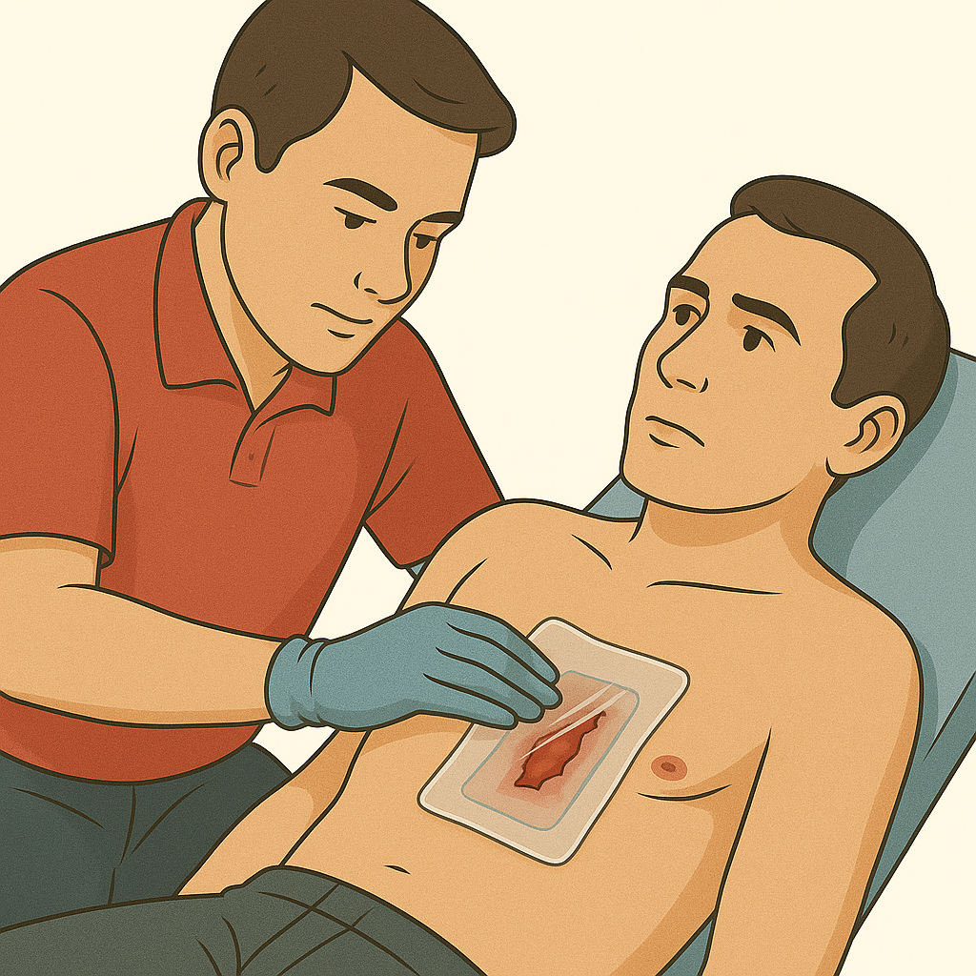

GLOSSARY OF TERMS
Sucking Chest Wound: An injury in which a hole in the chest wall allows air to be drawn into the chest cavity with each breath.
Non-Occlusive Dressing: A dressing that allows air to escape and prevents pressure buildup — safer for chest injuries.
Occlusive Dressing: A special dressing that completely seals the chest wound to prevent air from entering the chest cavity.
Tension Pneumothorax: A life-threatening condition in which trapped air in the chest cavity compresses the lung and heart. Incorrect sealing of the wound (for example, taping all four sides) can cause this condition.
Semi-Fowler Position: A position in which the patient is placed in a semi-upright posture (head and chest elevated at about 30–45 degrees).

