SCENARIO 1: Resuscitation of an Adult in Cardiac and Respiratory Arrest During an Earthquake

What is learning outcome?
HARD skills:
Participants receiving this training:
- Recognizes cardiac and respiratory arrest.
- Creates a safe environment for intervention.
- Applies the steps of Basic Life Support (BLS) in the correct order (ABC approach).
- Performs chest compressions at the correct rate and depth.
- Uses the Automated External Defibrillator (AED) correctly.
SOFT skill:
Participants receiving this training:
- Remains calm and in control during emergencies.
- Acts quickly and effectively in decision-making processes.
- Communicates clearly and gives guiding instructions to people around.

Description of the situation: (For all scenarios, descprition of situation will be differrent )
Near the edge of a collapsed building, the user identifies an adult male lying motionless on the ground. His body is partially covered in dust and debris, indicating possible trauma. As the user approaches, it becomes evident that the individual is unresponsive. There is no visible chest movement, no audible breath sounds, and no signs of circulation. A carotid pulse check confirms cardiac arrest.
This is a critical life-threatening emergency. The participant must first ensure the scene is safe and then promptly begin a basic life support (BLS) protocol. This includes assessing responsiveness, opening the airway, checking for breathing and pulse, and immediately initiating CPR.
The simulation is designed to respond dynamically to the user’s actions:

✅ Correct and timely interventions (e.g., high-quality CPR, use of AED) may lead to the return of spontaneous circulation and breathing.
❌ Incorrect, delayed, or omitted actions will cause the patient’s condition to deteriorate, potentially leading to irreversible shock or death.
Description of the environment: (For all scenarios, description of the environment will be same)
The scenario takes place in a densely populated urban neighborhood that has been severely impacted by a recent earthquake. The surroundings are chaotic and hazardous. Collapsed buildings dominate the landscape, and large piles of debris obstruct the streets and sidewalks. There is a fire and heavy water flow around. A thick layer of dust hangs in the air, limiting visibility. Sounds of distress echo in the background—shouts for help, distant sirens, and the occasional rumble of aftershocks. Structural instability is evident, with partially damaged walls swaying slightly and loose objects scattered across the area.
Despite the devastation, several disoriented bystanders are present, standing at a distance in shock and confusion.

Interaction – what should the participant do:
Initial safety check:
The participant moves through the debris-filled area.
    - “Let’s check the surroundings. We need to find a safe spot.”

Check the surroundings: find a safe place

Identifying the injured person:
A scene shows a conscious adult lying on the ground
There is an injured and unconscious person here! I will call 112

    - “There is an injured person here! He looks unconscious. We need to intervene immediately.”
    - "Alright, I’ll call 112 and request emergency assistance."
Situation assessment:
- The participant kneels next to the individual, touches his/her shoulder, and says, “Can you hear me?”.

Can you hear me?”

✅ System feedback: “No response from the patient.”

❌

Begin chest compressions

✅

Check breathing

Step 1: Breathing check:
Participant
- Puts fingers in the patient’s mouth to check whether there are foreign objects in the mouth of the individual and remove them.
- Holds the individual's forehead and tilts his/her head back by lifting the chin point with his/her fingers.
- Checks whether he/she hears breathing sound by putting his/her ear close to the mouth and nose of the individual.
- Attempts to feel the breath coming from the individual's mouth or nose on his/her cheeks.
No breathing

- Gives vocal feedback as “not breathing.”
- Activates the speakerphone or “hands-free” feature of the phone so that he/she can stay with the individual and start CPR while talking to the attendant.

✅
Check pulse

❌

Give direct mouth-to-mouth breathing

Step 2: Circulation check:
Participant
- Places the fingers on the side of the neck, right next to the larynx (Adam's apple).
No pulse

- Gives vocal feedback as “no pulse”.

Chest Compression, Respiration and Automated External Defibrillator (AED) Application
- The participant is expected to perform the following steps:

✅

30 chest compression+2 breathing

❌

10 chest compression+5 breathing

Step 3: Chest compression:
Participant
- Lays the individual on their back on the hard floor
- Centers the individual's breastbone (sternum) and determines the midpoint of the sternum, places the hand on the lower half of the sternum.
- Holds the hand exactly on the sternum.
- Keeps the hands steady, the elbows and shoulders straight and perpendicular to the patient's body.
- While the participant's arms are in a perpendicular position and tense to the individual's chest, pushes the sternum down (the compression depth is 5-6 cm) by applying body weight and releases the ribcage without lifting their hands.
- Performs 30 heart massages, then gives 2 breaths.
- The chest compression rate is 100-120 compressions per minute, the compression depth is 5-6 cm.

Step 4: Artificial respiration:
Participant
- The participant places one hand on the individual's forehead.
- Place fingers of the other hand on the individual's chin.
- The head is pushed back, and the chin is lifted. (a head-chin position).
- Place the pocket mask with the narrow end at the bridge of the nose, covering both the nose and mouth.
- Creates a tight seal on the mask using both hands (thumb and index finger form a “C” on the mask rim; the other fingers lift the jaw to maintain the airway).
- Delivers rescue breaths through the one-way valve: place your lips fully around the valve (or mouthpiece) to create an airtight seal; one breath over about 1 second, watching for visible chest rise; allows full exhalation.
- Gives two artificial respirations through the airway.
- Artificial respiration is performed 12 times per minute, and the amount of air is such that the chest cage is lifted.

Step 5: AED usage:

❌

Open the device and place the pads at shoulder and belly level.

✅

Open the device and place the pads above the right breast and below the left breast.

Participant
    - Opens the device and places the electrode pads.
    - Places one of the pads on the right upper chest (under the collarbone) and the other just below the left lower rib (near the armpit).
Stand clear of the patients

    - The AED provides a voice prompt: “Stand clear of the patient.”
    - The device analyzes the rhythm.
Shock can be applied

    - The AED provides a voice prompt: “Shock can be applied.”
Press the shock button

    - The AED then prompts: “Press the shock button.”
    - Participant presses the shock button, then continues CPR.

After giving a shock, chest compression is started again. This process is repeated about 5 cycles for 2 minutes.
- After 2 minutes, the participant checks the pulse of the carotid artery.
- “OK, he/she started breathing! We did it!”
"Now we are waiting for the ambulance to arrive. Let’s place him/her to the recovery position”
Tools and objects
Notes for developers:
- All tools should be interactive, with grabbable or drag-and-drop mechanics.
- AED must include voice instructions and error detection (e.g., wrong pad placement).
- Tools must only be available at relevant points in the scenario to guide proper sequencing.
- If UI is used: each object should include labels and short tooltips

Tool/Object | Description | Purpose of Use | Visual Reference (example)
CPR manikin | Adult-sized training dummy with realistic chest recoil and airway features | For chest compressions and rescue breaths | 🧍‍♂️ Medical training manikin
Automated external defibrillator (AED) | With screen, voice prompts, and electrode pads | To analyze heart rhythm and deliver a shock if needed | ⚡ AED device with display and buttons
Defibrillator pads | Adhesive electrodes placed on the upper right chest and lower left rib area | To deliver shock from AED to the patient | 🔲 Stick-on chest pads
Pocket mask | One-way valve mask small enough to carry in a pocket | For more hygienic and effective rescue breathing | 😷 Transparent CPR mask with strap

Evaluation and feedback
Performance analysis:
- Data such as the number, depth and rhythm of chest compressions performed by the participant are analyzed.
- The effectiveness and appropriateness of artificial breathing is evaluated.
Suggestion for improvement:
- Strengths and weaknesses are reported to the participant (e.g., “Your CPR rhythm was excellent, but pay more attention to breath control”).
Score and certification:
Participants demonstrating successful performance can earn a digital certificate of achievement.

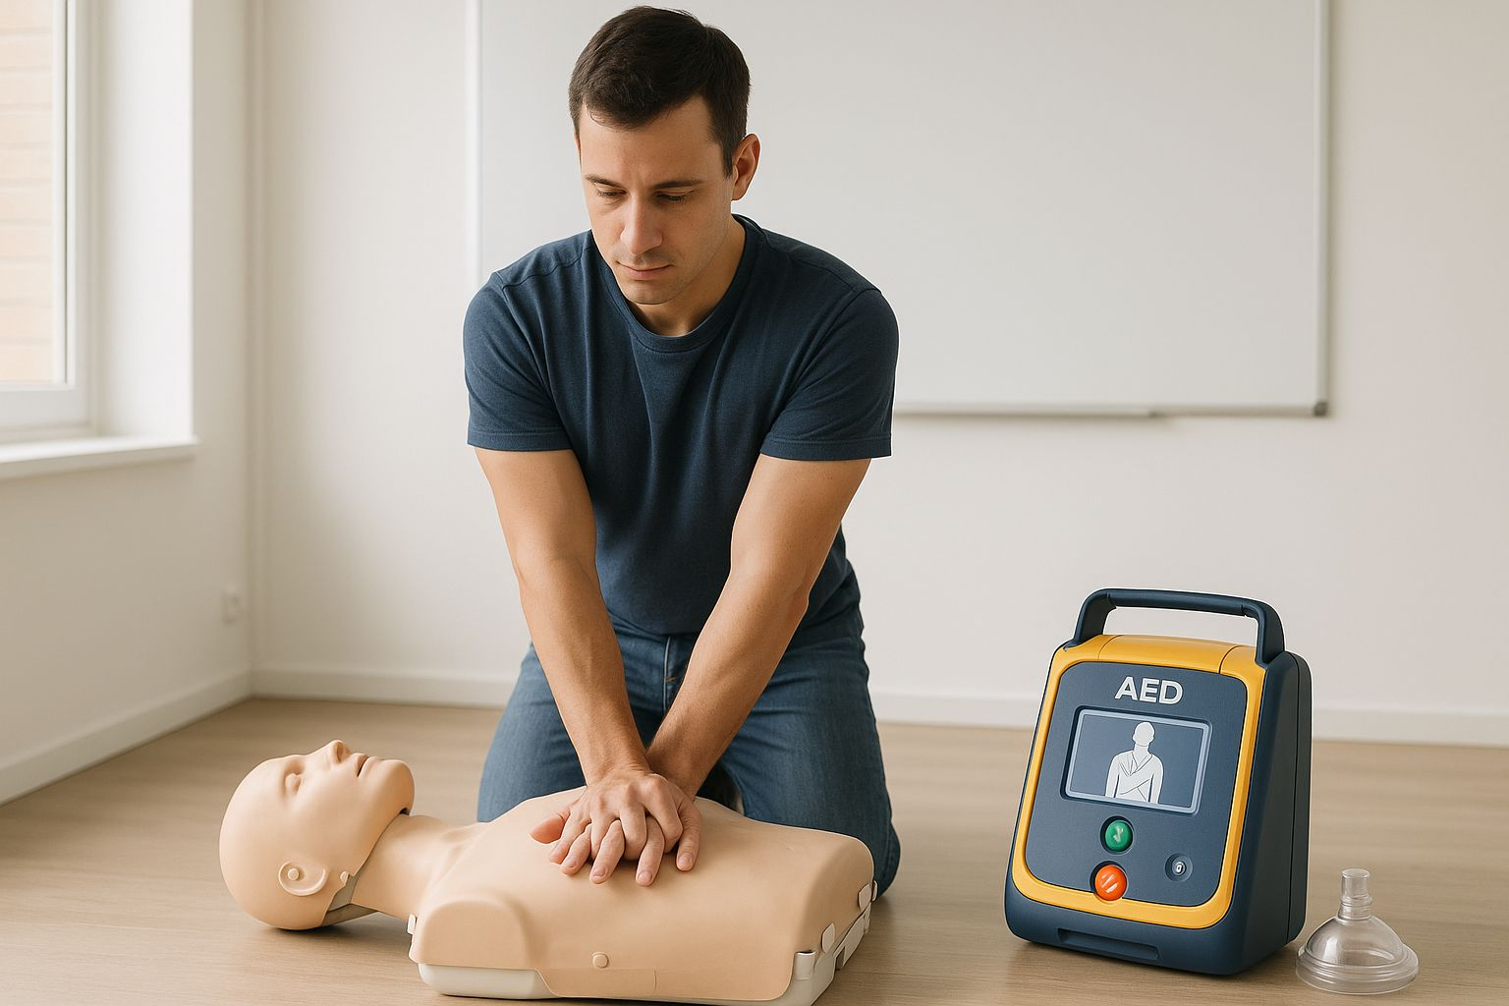

GLOSSARY OF TERMS
ABC Approach: Airway, Breathing, Circulation - systematic assessment
AED: Automated External Defibrillator
BLS: Basic Life Support
CPR: Cardiopulmonary Resuscitation
Cardiac Arrest: Sudden loss of heart function
Carotid Pulse: Pulse on neck
Compression Depth: 5-6 cm for adults
Compression Rate: 100-120 per minute
Recovery Position: Side-lying position
ROSC: Return of Spontaneous Circulation

